Experimental Design

Overview

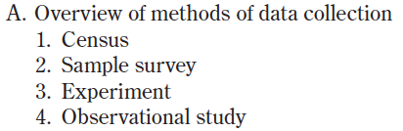
Planning and conducting a study (10%-15%)
Data must be collected according to a well-developed plan if valid information on a conjecture is to be obtained. This includes clarifying the question and deciding upon a method of data collection and analysis.
II. Sampling and Experimentation
- Which of the following is a key distinction between well designed experiments & observational studies?

(A) More subjects are available for experiments than for observational studies.
(B) Ethical constraints prevent large-scale observational studies.
(C) Experiments are less costly to conduct than observational studies.
(D) An experiment can show a direct cause-and-effect relationship, whereas an observational study cannot.
(E) Tests of significance cannot be used on data collected from an observational study.

25. A new medication has been developed to treat sleep-onset insomnia (difficulty in falling asleep). Researchers want to compare this drug to a drug that has been used in the past by comparing the length of time it takes subjects to fall asleep. Of the following, which is the best method for obtaining this information?

(A) Have subjects choose which drug they are willing to use, then compare the results.
(B) Assign the two drugs to the subjects on the basis of their past sleep history without randomization, then compare the results.
(C) Give the new drug to all subjects on the first night. Give the old drug to all subjects on the second night. Compare the results.
(D) Randomly assign the subjects to two groups, giving the new drug to one group and no drug to the other group, then compare the results.
(E) Randomly assign the subjects to two groups, giving the new drug to one group and the old drug to the other group, then compare the results.

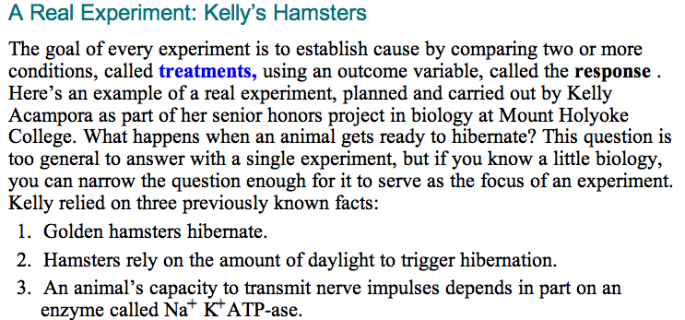
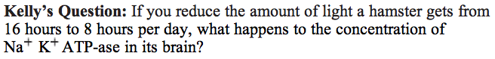
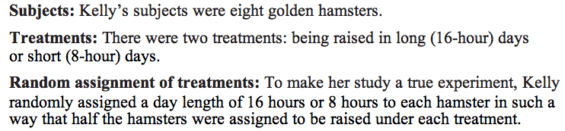
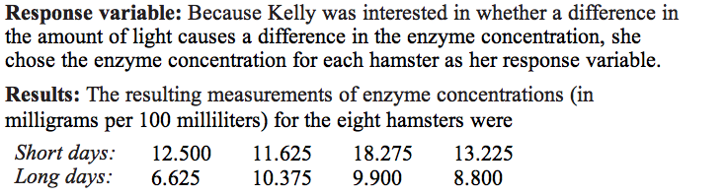
Characteristics of a Well Designed Experiment

Experimental Units, Factors, Levels, and Treatments
Experimental Units: The individual units of study

Factors: The variables of interest in an experiment

Levels: The values of those variables

Treatments: Each combination of levels, one from each factor

The experimental units are the things to which treatments are randomly assigned.

- A mathematics education researcher was interested in determining the effects of class size (small, medium, or large) and the use of a traditional statistics textbook versus a new textbook. The researcher conducted her own experiment, assigning each combination of class size and type of textbook to two classes at each of five chosen schools. The average final grade for the class was then recorded at the end of the year.

  - What are the factors? What are the levels?

  - What are the treatments?

  - What are the experimental units? How many are there?

  - What is the response variable?
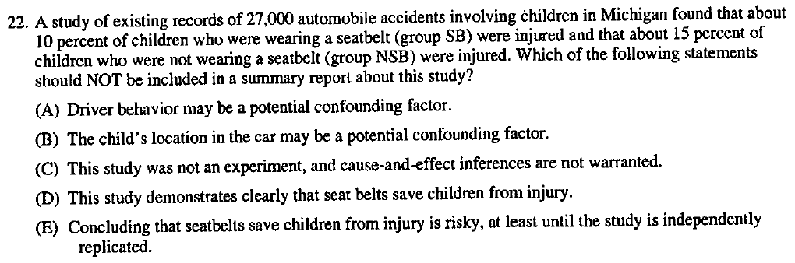

What is confounding?

When there is more than one possible cause for a change in response variable, and the effects cannot be separated.

How is confounding present in that last question?

